Capstone Project

# TELECOM CHURN ANALYSIS

**Bhuvneshwar Pal**

# Objective

**Explore and analyze the data to discover key factors responsible for customer churn and come up with recommendations to ensure customer retention.**



# Deﬁnitions

### Churn = describes customer loss for a company.

**Churn rate = rate at which customers of a business are leaving within a speciﬁc time period.**

# Dataset information

## Orange telecom dataset description-

1. **.csv ﬁle with 3333 non-null entries**

## 20 features

1. **attributes related to state, charges, calls and services.**
2. **Churn a boolean(True/False) variable showing customer churned or not.**

# Exploratory Data Analysis

**Some key observations-**

### Orange telecom provides services in 51 states.

* **West Virginia having maximum and California with minimum observations.**

### International plan (having 323 customers) and Voicemail plan (having 922 customers) are add-on services and we have a total of 3333 customers.

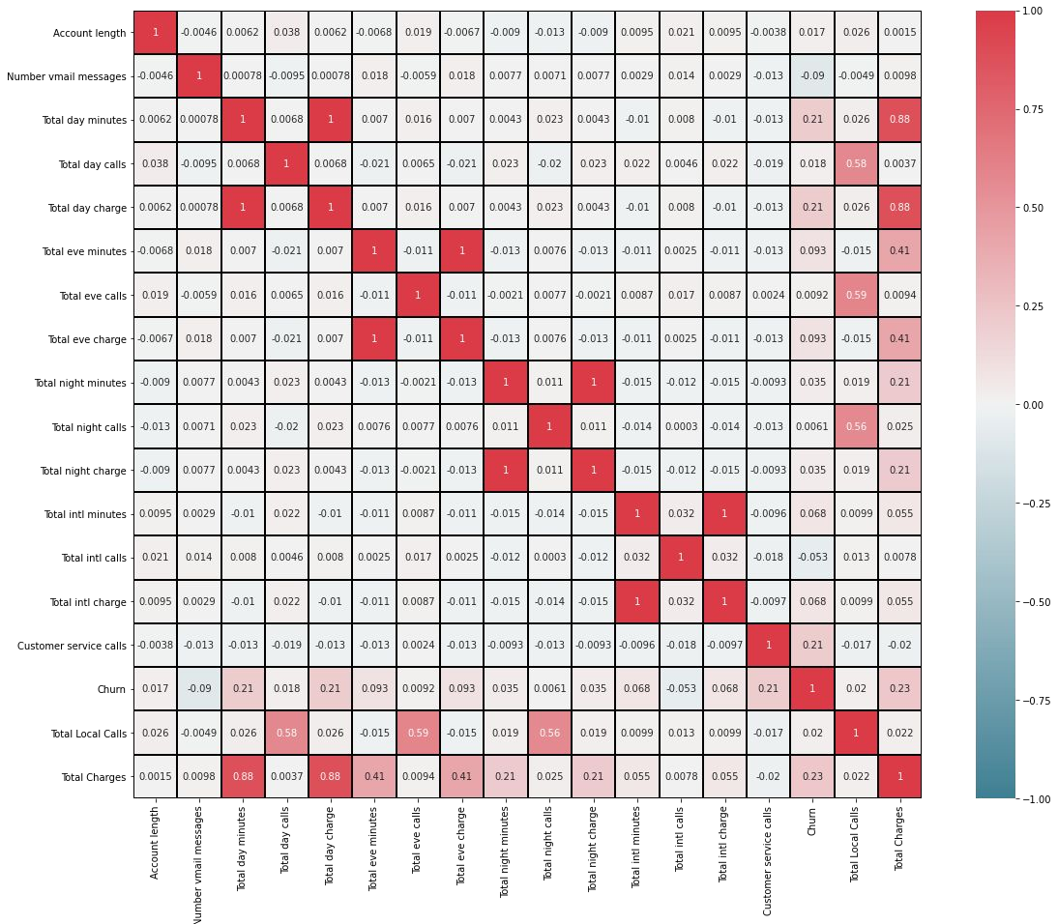

EDA (contd..)

How everything in dataset is correlated?

Charges & customer service calls are clearly leading to churn with same magnitude.

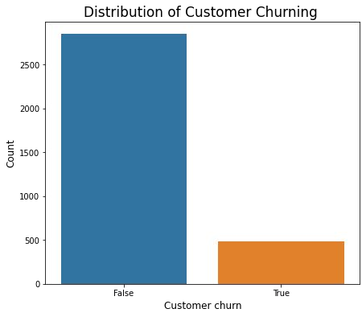

**Analysing churn-**

## 483 out of 3333 customers churned (14.49% loss)

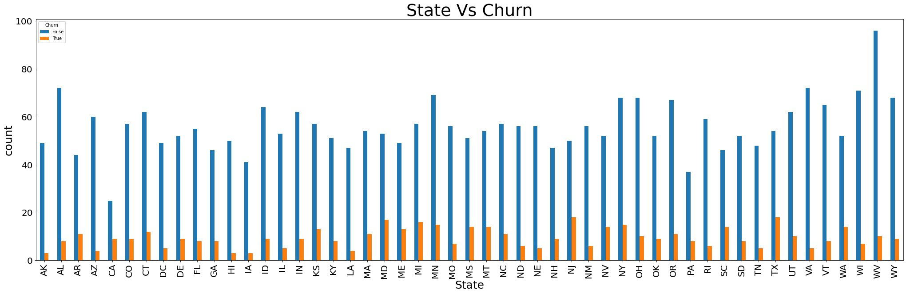

### Observing state wise trend of #subscribers and churn-

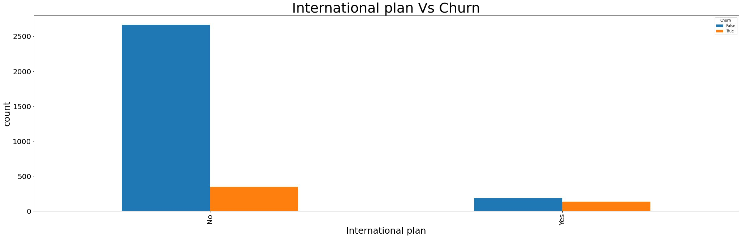

**Churning and add-on services analysis-**

323 customers opted for Intn’l plan but 137 churned i.e. 42.4% loss.

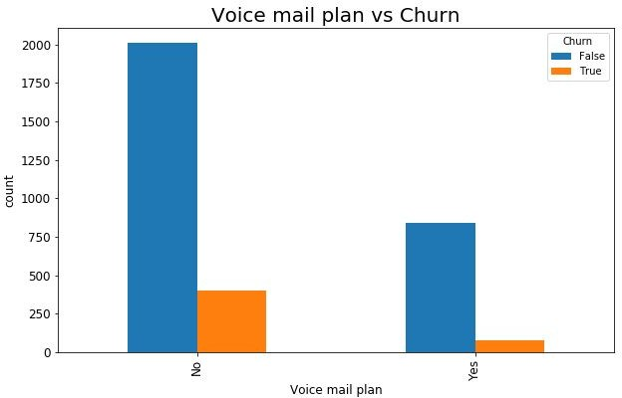922 (28%) customers are using Voicemail services and 80 of them are churning. For this service domain we have 8.6% ~9% loss.

### Company need to focus on these add-on services.

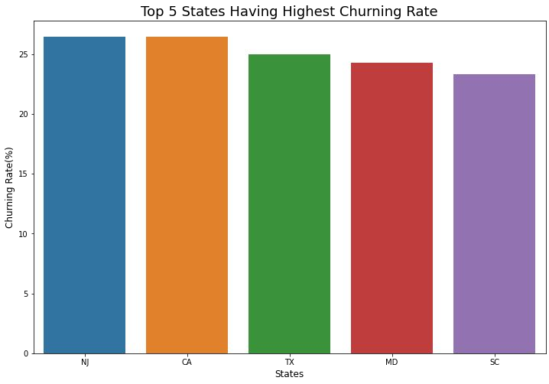

New Jersey California Texas Maryland South Carolina

are the states where churning rates are high.

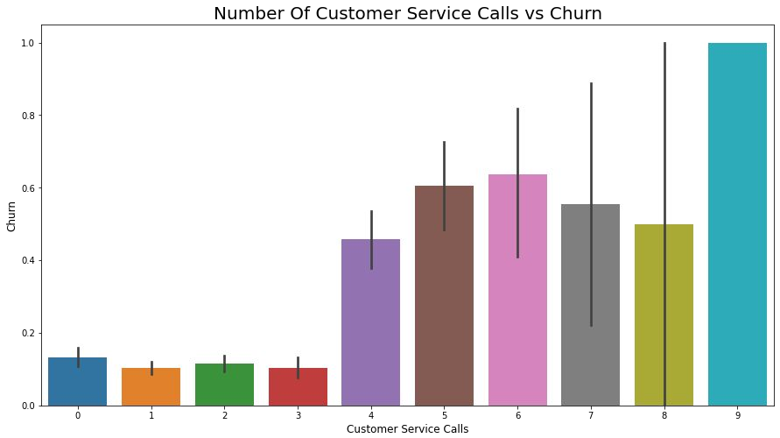Churning and company core services analysis-

Customers calling in customer care services > 3 times are more likely

to churn.

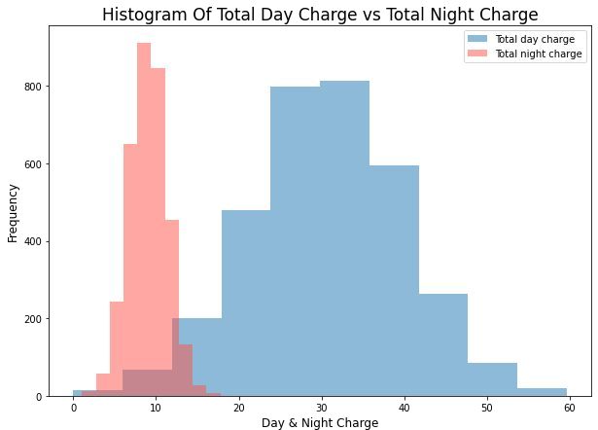

Distribution of day & night charges

Most of the revenue comes from the daytime charges but this spectrum of customers churns frequently.

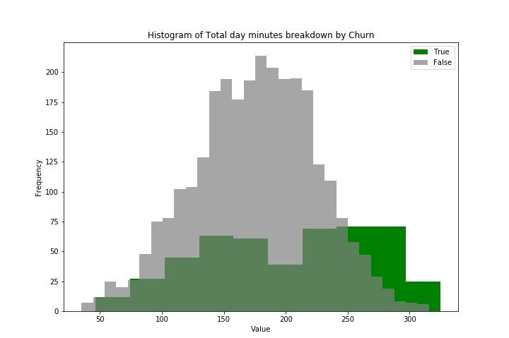Histogram of Total Day Minutes and Total Charges breakdown by Churn

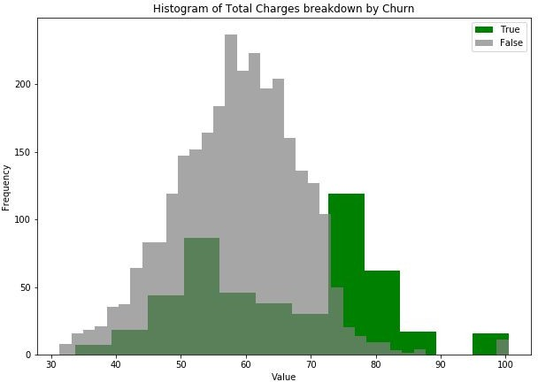

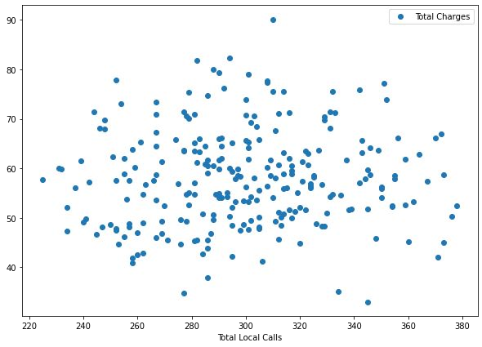

Distribution of Total local calls & charges

More subscribers are making around

275-325 total local calls.

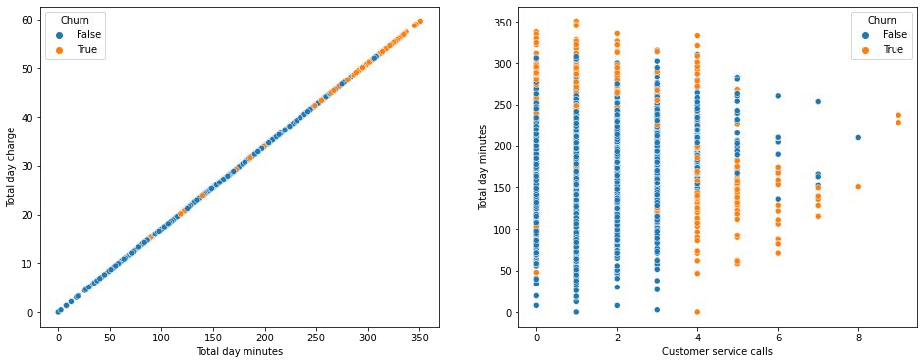

Churning association with charges and total day minutes- More charges are leading to more churning.

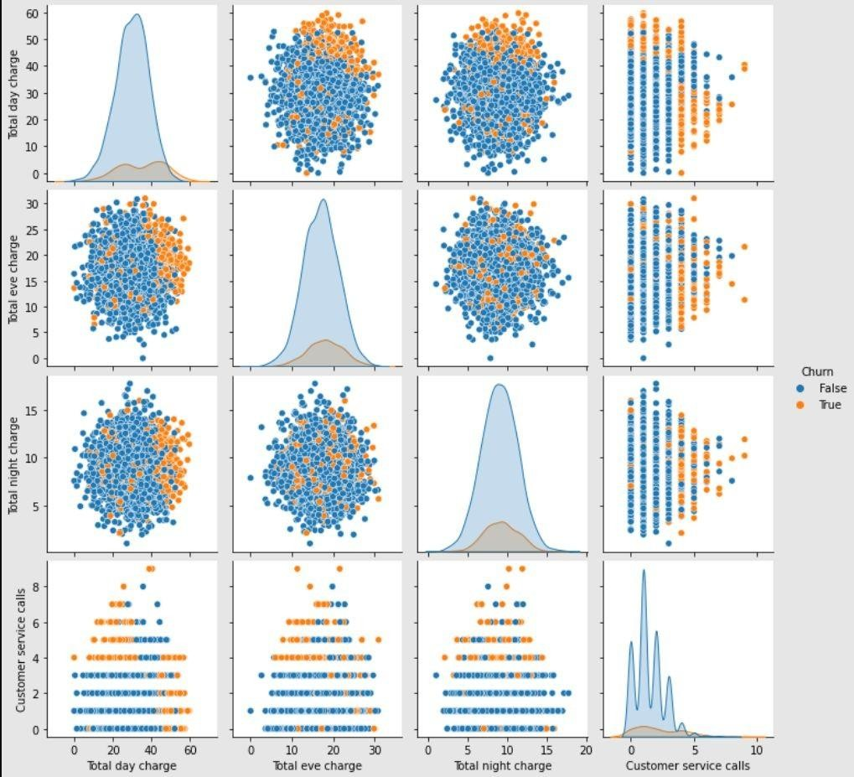

EDA (contd..)

Visualisation of relationship between each variable for instant examination using pairplot.

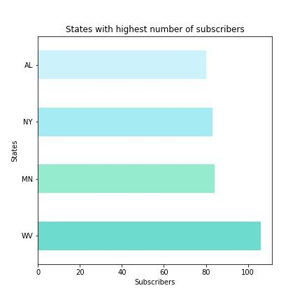

These 4 states have highest number of customers.

West Virginia has highest number of subscribers.

Our analysis shows that NY is having 18% churning rate.



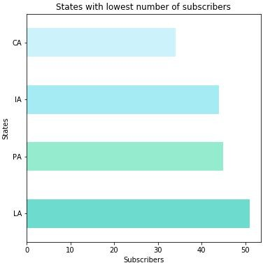These 4 states have lowest number of customers.

California have only 34 customer but our analysis Shows that 9 churned

(1 in every 4 customer is leaving).

**Recommendations:-**

* **Orange telecom need more infrastructure in terms of marketing, technology and services in top 5 states having highest churning rate**

along with lowest customers especially in CA and also in NY to reduce churning.

* **Orange telecom can introduce proﬁtable market strategy such as exclusive offers.**
* **The company can reduce daytime calling charges.**
* **Add-on services like voicemail plan, international plan and customer care satisfaction are required to be revamp.**

## Thank you!!

